Beer
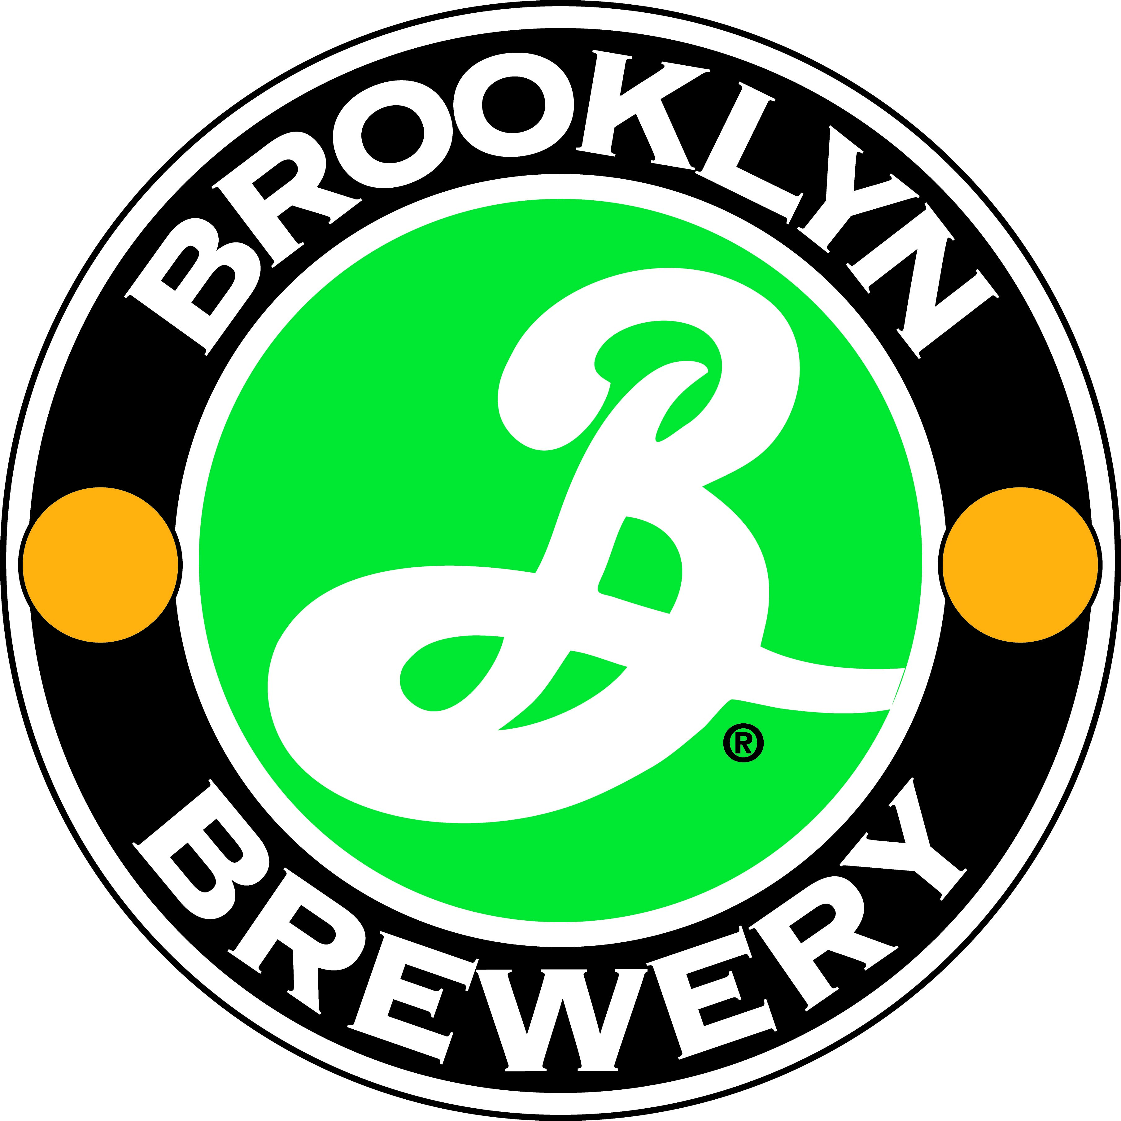
Brooklyn brewery – Brooklyn, NY (www.brooklynbrewery.com)
+7293 Brooklyn Lager 6 x 355ml - $ 91 points Gismondi

WINE
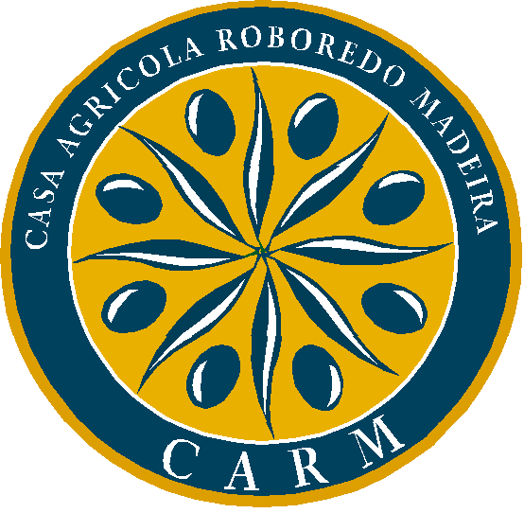
CARM – Douro Portugal
+6170 Douro CARM 2005 – $19.99 – 88 points Gismondi “ORGANIC”-”SMART BUY”

SPIRITS

Boomsma Distillery – Holland
+6152 Geneva Gin -$28.75

