Beer
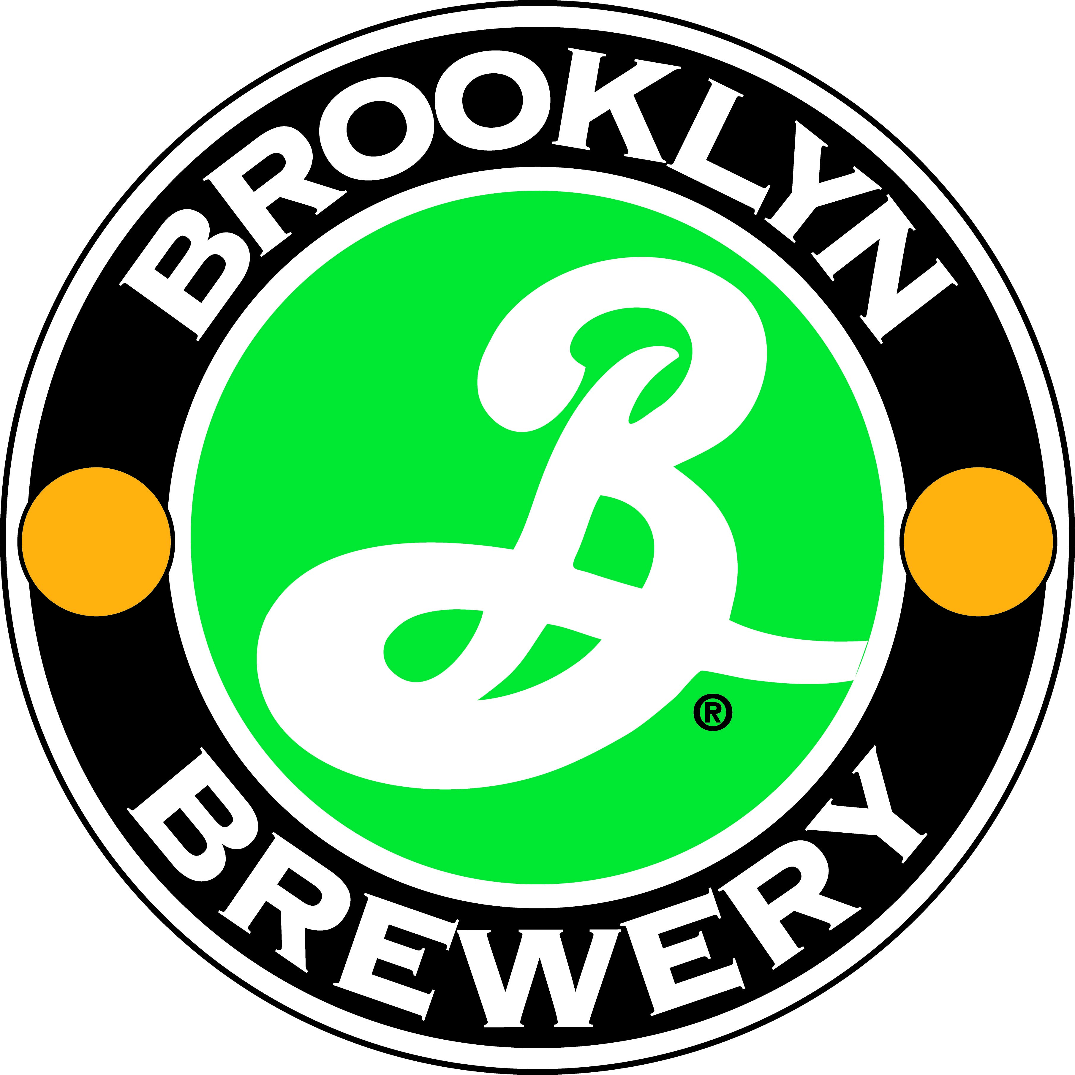
Brooklyn brewery – Brooklyn, NY (www.brooklynbrewery.com)
26997 Brooklyn Lager 6 x 355ml - $12.99 - 91 points Gismondi

Brooklyn Lager On Draft as well thru the Beer Stores.

